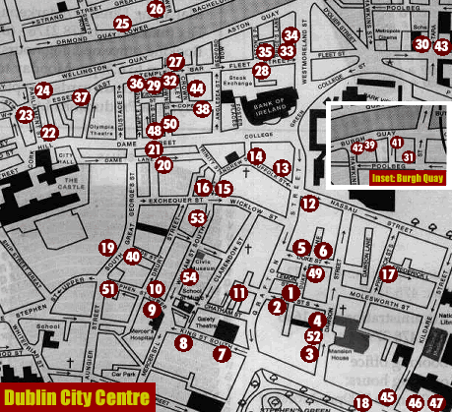
1 = Kehoe's  2 = Davy Byrne's  3 = Dawson Lounge  4 = Cafe en Seine  5 = The Bailey  6 = The Duke  7 = Sinnott's  8 = Major Tom's  9 = Break for the Border  10 = Hairy Lemon  11 = McDaid's  12 = Judge Roy Bean's  13 = Thinge Mote  14 = O'Neill's  15 = International Bar  16 = Old Stand  17 = Renards  18 = O'Donoghue's  19 = The Long Hall  20 = Stag's Head  21 = The Mercantile  22 = The Oak/Thomas Read's  23 = Turk's Head  24 = The Porterhouse  25 = Zanzibar  26 = Pravda  27 = The Quays  28 = Gogarty's  29 = Temple Bar  30 = McTurkel's | 31 = Mulligan's  32 = The Auld Dubliner  33 = The Palace Bar  34 = The Bridge  35 = Buskers  36 = The Norseman  37 = Bob's  38 = Club M (nightclub)  39 = Messers Maguire  40 = Hogan's  41 = McCormack's  42 = Q Bar  43 = Fireworks,Tara Street  44 = Eamonn Doran's  45 = Foley's  46 = Doheny & Nesbits  47 = Toner's  48 = Oliver Goldsmith's  49 = Cocoon  50 = Foggy Dew  51 = Capital Bar  52 = SamSara  53 = Dakota  54 = Viva
Where to find those pubs in Dublin

Put your company or brand name on the map
This is the most popular part of DublinPubs.net
Thousands of people have used this map. So to promote your brand or service to a captive market, contact Andy Gilleran.
Email: advertise@dublinpubs.net
Your FREE map to Dublin pubs.
Print out and keep safely.
Your liver depends on it… :-)

